**NUMBER THEORY**

**IMPLEMENTATION OF EUCLIDEAN ALGORITHM**

**TO FIND THE GCD BETWEEN TWO NUMBERS**

**EX.NO. : 1a**

**DATE :**

**AIM:**

To implement Euclidean Algorithm to find the gcd between two numbers

**ALGORITHM :**

1.Start

2. Define a function by taking two variables as parameters

3. Repeat steps 4 to 7 until a and b are not equal to 0

4. Find the modulo value of a and b

5. Put a=b and b = modulo value

6. If b equals 0 return a

7. Otherwise go to step 2 by passing new values of a and b

8. Stop

**SOURCE CODE :**

#include<stdio.h>

int euclid(int a ,int b){

while(a!=0 && b!=0){

int c = a%b;

a=b;

b=c;

if(b==0)

{

return a;

}

else{

euclid(a,b);

}

}

}

void main(){

int a,b,gcd;

printf("Enter the values of a:");

scanf("%d",&a);

printf("Enter the value of b:");

scanf("%d",&b);

gcd = euclid(a,b);

printf("The GCD of the two numbers using Euclid algorithm is %d\n",gcd);

}

**OUTPUT :**

Enter the values of a:192

Enter the value of b:270

The GCD of the two numbers using Euclid algorithm is 6

**RESULT :**

Thus the euclidean algorithm to find the gcd of two numbers has been executed successfully

**NUMBER THEORY**

**IMPLEMENTATION OF EXTENDED EUCLIDEAN ALGORITHM**

**TO FIND THE INVERSE MODULO**

**EX.NO. : 1b**

**DATE :**

**AIM:**

To implement Extended Euclidean Algorithm to find the inverse modulo

**ALGORITHM :**

1.Start

2. Define a function to find the inverse modulo using extended euclids algorithm

3. Check if a is equal to 0

4. If a =0 then assign the value of the pointer x to be 0 and pointer y to be 1

5.Return the value of b

6. Otherwise call this function recursively by passing the modulo of a and b and the values of _x and _y

7.Update the values of the pointes and return the gcd value

8. Stop

**SOURCE CODE :**

#include <stdio.h>

int extended_gcd(int a, int b, int *x, int *y)

{

if (a == 0)

{

*x = 0;

*y = 1;

return b;

}

int _x, _y;

int gcd = extended_gcd(b % a, a, &_x, &_y);

*x = _y - (b/a) * _x;

*y = _x;

return gcd;

}

int main()

{

int a,b;

printf("Enter a:");

scanf("%d",&a);

printf("Enter b:");

scanf("%d",&b);

int x, y;

printf("The GCD is %d\n", extended_gcd(a, b, &x, &y));

printf("The inverse modulo value is = %d",x);

return 0;

}

**OUTPUT :**

Enter a:15

Enter b:26

The GCD is 1

The inverse modulo value is = 7

**RESULT :**

Thus the extended euclidean algorithm to find the inverse modulo has been executed successfully

**NUMBER THEORY**

**IMPLEMENTATION OF EULER TOTIENT FUNCTION**

**EX.NO. : 1c**

**DATE :**

**AIM:**

To write a program to implement Euler Totient Function

**ALGORITHM :**

1. Start

2. Check if n is prime or not

3. If the number is prime then the Euler totient function will be n-1

4. If the number is composite then find the prime factors of the number

5. If the factors have exponents then the Euler totient function is pa -pa-1  * Eulter totient function of the non exponent prime factor

6. Stop

**SOURCE CODE :**

#include<stdio.h>

int gcd(int a,int b){

if(a==0){

return b;

}

return gcd(b%a,a);

}

int phi(unsigned int n){

unsigned int result = 1;

int i;

for( i=2;i<n;i++){

if(gcd(i,n)==1){

result++;

}

}

return result;

}

int main(){

int n;

printf("Enter a number");

scanf("%d",&n);

printf("phi(%d) = %d\n",n,phi(n));

return 0;

}

**OUTPUT :**

Enter a number80

phi(80) = 32

**RESULT :**

Thus the program to implement euler totient function is executed successfully

**NUMBER THEORY**

**IMPLEMENTATION OF MILLER RABIN PRIMALITY CHECK**

**EX.NO. : 1d**

**DATE :**

**AIM:**

To write a program to implement Miller Rabin Primality Check

**ALGORITHM :**

1..Start

2.Find integers k,q,d with K>0, q odd, so that (n-1 = 2^k * q);

3. Select a random integer a,1<a<n-1;

4. if a^q mod n = 1 then return prime;

5. for j = 0 to k-1 do;

6. if a^2jq mod n = n-1 then return prime;

7. return not prime

8. Stop

**SOURCE CODE :**

#include<stdio.h>

#include<string.h>

#include<stdlib.h>

long long mulmod(long long a,long long b,long long mod){

long long x =0,y=a%mod;

while(b>0){

if(b%2==1){

x = (x+y)%mod;

}

y=(y*2)%mod;

b/=2;

}

return x%mod;

}

long long modulo(long long base,long long exponent,long long mod){

long long x=1;

long long y=base;

while(exponent>0){

if(exponent %2 ==1){

x=(x*y)%mod;

y=(y*y)%mod;

exponent = exponent/2;

}

return x%mod;

}}

int miller(long long p,int iteration){

int i;

long long s;

if(p<2){

return 0;

}

if(p!=2 && p%2==0){

return 0;

}

s = p-1;

while(s%2==0){

s/=2;

}

for(i=0;i<iteration;i++){

long long a = rand()%(p-1)+1,temp=s;

long long mod = modulo(a,temp,p);

while(temp!=p-1 && temp%2==0){

return 0;

}

}

return 1;

}

main(){

int iteration =5;

long long num ;

printf("Enter a number to test:");

scanf("%lld",&num);

if(miller(num,iteration)){

printf("The number is prime");

}

else{

printf("Number is not prime");

}

return 0;

}

**OUTPUT :**

Enter a number to test:1729

The number is prime

**RESULT :**

Thus the program to implement Miller Rabin Primality Check is executed successfully

**SUBSTITUTION CIPHERS**

**IMPLEMENTATION OF CAESAR CIPHER**

**EX.NO. : 2a**

**DATE :**

**AIM:**

To write a program to implement Caesar Cipher

**ALGORITHM :**

1. Start

2. Take the message and the key as input from the user

3. Add each character of the message with the key by using the ascii value of the characters

4. Repeat the same step for Upper case alphabets also.

5.Print the cipher text

6. For Decryption Process subtract the value of the key from the acscii value of the cipher text

7. Stop

**SOURCE CODE :**

**ENCRYPTION:**

#include<stdio.h>

int main(){

char message[100],ch;

int i,key;

printf("Enter the message to encrypt");

gets(message);

printf("Enter Key");

scanf("%d",&key);

for(i=0;message[i]!='\0';++i){

ch = message[i];

if(ch>='a'&&ch<='z'){

ch=ch+key;

if(ch>'z'){

ch = ch-'z'+'a'-1;

}

message[i]=ch;

}

else if(ch>='A' && ch<='Z'){

ch=ch+key;

if(ch>'Z'){

ch = ch-'Z'+'A'-1;

}

message[i]=ch;

}

}

printf("Encrypted message using Caeser cipher is %s",message);

return 0;

}

**OUTPUT :**

Enter the message to encrypt:abcd

Enter Key4

Encrypted message using Caeser cipher is efgh

**DECRYPTION:**

#include<stdio.h>

int main(){

char message[100],ch;

int i,key;

printf("Enter the message to decrypt:");

gets(message);

printf("Enter Key: ");

scanf("%d",&key);

for(i=0;message[i]!='\0';++i){

ch = message[i];

if(ch>='a'&&ch<='z'){

ch=ch-key;

if(ch>'z'){

ch = ch-'z'+'a'-1;

}

message[i]=ch;

}

else if(ch>='A' && ch<='Z'){

ch=ch-key;

if(ch>'Z'){

ch = ch-'Z'+'A'-1;

}

message[i]=ch;

}

}

printf("Decrypted message using Caeser cipher is %s",message);

return 0;

}

**OUTPUT:**

Enter the message to decrypt: efgh

Enter Key: 4

Decrypted message using Caeser cipher is abcd

**RESULT :**

Thus the program to implement Caesar Cipher is executed successfully

**SUBSTITUTION CIPHERS**

**IMPLEMENTATION OF PLAYFAIR CIPHER**

**EX.NO. : 2b**

**DATE :**

**AIM:**

To write a program to implement PlayFair Cipher

**ALGORITHM :**

1. Start

2.Take the plain text and key as input.

3. Divide the text into letters of two letters and use fillers such as x

4. Construct a table with the key and fill the remaining spaces of the table with the remaining alphabets

5. Find the cipher text by checking the row and the column of the plain text in the table.

6. If they are in different rows then find the rowwise and columnwise intersection and consider it to be the cioher text.

7. If they are in the same row then take the next characters to be the cipher text.

8. Print the cipher text

9. Stop

**SOURCE CODE :**

#include <bits/stdc++.h>

using namespace std;

typedef struct{

int row;

int col;

}position;

char mat[5][5]; // Global Variable

void generateMatrix(string key)

{

/* flag keeps track of letters that are filled in matrix */

/* flag = 0 -> letter not already present in matrix */

/* flag = 1 -> letter already present in matrix */

int flag[26] = {0};

int x = 0, y = 0;

/* Add all characters present in the key */

for(int i=0; i<key.length(); i++)

{

if(key[i] == 'j') key[i] = 'i'; // replace j with i

if(flag[key[i]-'a'] == 0)

{

mat[x][y++] = key[i];

flag[key[i]-'a'] = 1;

}

if(y==5) x++, y=0;

}

/* Add remaining characters */

for(char ch = 'a'; ch <= 'z'; ch++)

{

if(ch == 'j') continue; // don't fill j since j was replaced by i

if(flag[ch - 'a'] == 0)

{

mat[x][y++] = ch;

flag[ch - 'a'] = 1 ;

}

if(y==5) x++, y=0;

}

}

/* function to add filler letter('x') */

string formatMessage(string msg)

{

for(int i=0; i<msg.length(); i++)

{

if(msg[i] == 'j') msg[i] = 'i';

}

for(int i=1; i<msg.length(); i+=2) //pairing two characters

{

if(msg[i-1] == msg[i]) msg.insert(i, "x");

}

if(msg.length()%2 != 0) msg += "x";

return msg;

}

/* Returns the position of the character */

position getPosition(char c)

{

for(int i=0; i<5; i++)

for(int j=0; j<5; j++)

if(c == mat[i][j])

{

position p = {i, j};

return p;

}

}

string encrypt(string message)

{

string ctext = "";

for(int i=0; i<message.length(); i+=2) // i is incremented by 2 inorder to check for pair values

{

position p1 = getPosition(message[i]);

position p2 = getPosition(message[i+1]);

int x1 = p1.row; int y1 = p1.col;

int x2 = p2.row; int y2 = p2.col;

if( x1 == x2 ) // same row

{

ctext += mat[x1][(y1+1)%5];

ctext += mat[x2][(y2+1)%5];

}

else if( y1 == y2 ) // same column

{

ctext += mat[ (x1+1)%5 ][ y1 ];

ctext += mat[ (x2+1)%5 ][ y2 ];

}

else

{

ctext += mat[ x1 ][ y2 ];

ctext += mat[ x2 ][ y1 ];

}

}

return ctext;

}

string Decrypt(string message)

{

string ptext = "";

for(int i=0; i<message.length(); i+=2) // i is incremented by 2 inorder to check for pair values

{

position p1 = getPosition(message[i]);

position p2 = getPosition(message[i+1]);

int x1 = p1.row; int y1 = p1.col;

int x2 = p2.row; int y2 = p2.col;

if( x1 == x2 ) // same row

{

ptext += mat[x1][ --y1<0 ? 4: y1 ];

ptext += mat[x2][ --y2<0 ? 4: y2 ];

}

else if( y1 == y2 ) // same column

{

ptext += mat[ --x1<0 ? 4: x1 ][y1];

ptext += mat[ --x2<0 ? 4: x2 ][y2];

}

else

{

ptext += mat[ x1 ][ y2 ];

ptext += mat[ x2 ][ y1 ];

}

}

return ptext;

}

int main()

{

string plaintext;

cout << "Enter message : "; cin >> plaintext;

int n; // number of keys

cout << "Enter number of keys : "; cin >> n;

string key[n];

for(int i=0; i<n; i++)

{

cout<< "\nEnter key " << i+1 << " : " << key[i];

cin >> key[i];

generateMatrix(key[i]);

cout << "Key " << i+1 << " Matrix:" << endl;

for(int k=0;k<5;k++)

{

for(int j=0;j<5;j++)

{

cout << mat[k][j] << " ";

}

cout << endl;

}

cout << "Actual Message \t\t: " << plaintext << endl;

string fmsg = formatMessage(plaintext);

cout << "Formatted Message \t: " << fmsg << endl;

string ciphertext = encrypt(fmsg);

cout << "Encrypted Message \t: " << ciphertext << endl;

string decryptmsg = Decrypt(ciphertext);

cout<< "Decrypted Message \t: " << decryptmsg << endl;

}

}

**OUTPUT :**

Enter message : india

Enter number of keys : 1

Enter key 1 : monarchy

Key 1 Matrix:

m o n a r

c h y b d

e f g i k

l p q s t

u v w x z

Actual Message : india

Formatted Message : indiax

Encrypted Message : gabkba

Decrypted Message : indiax

**RESULT :**

Thus the program to implement PlayFair Cipher is executed successfully

**SUBSTITUTION CIPHERS**

**IMPLEMENTATION OF HILL CIPHER**

**EX.NO. : 2c**

**DATE :**

**AIM:**

To write a program to implement Hill Cipher

**ALGORITHM :**

1. Start

2. Convert the given key into a matrix format by taking the corresponding numbers

3. Then convert the given plain text into a matrix format

4. Perform Matrix multiplication mod 26 of the matrices obtained in step 2 and 3

5. The convert the obtained number into a text to obtain the cipher text

6. To decrypt the cipher text multiply it with the inverse of the key matrix

7. Stop

**SOURCE CODE :**

#include<iostream>

#include<math.h>

using namespace std;

float encrypt[3][1], decrypt[3][1], a[3][3], b[3][3], mes[3][1], c[3][3];

void encryption();

void decryption();

void getKeyMessage();

void inverse();

int main() {

getKeyMessage();

encryption();

decryption();

}

void encryption() {

int i, j, k;

for(i = 0; i < 3; i++)

for(j = 0; j < 1; j++)

for(k = 0; k < 3; k++)

encrypt[i][j] = encrypt[i][j] + a[i][k] * mes[k][j];

cout<<"\ncipher text: ";

for(i = 0; i < 3; i++)

cout<<(char)(fmod(encrypt[i][0], 26) + 97);

}

void decryption() {

int i, j, k;

inverse();

for(i = 0; i < 3; i++)

for(j = 0; j < 1; j++)

for(k = 0; k < 3; k++)

decrypt[i][j] = decrypt[i][j] + b[i][k] * encrypt[k][j];

cout<<"\n De-ciphered text: ";

for(i = 0; i < 3; i++)

cout<<(char)(fmod(decrypt[i][0], 26) + 97);

cout<<"\n";

}

void getKeyMessage() {

int i, j;

char msg[3];

cout<<"\nkey [3x3]:\n";

for(i = 0; i < 3; i++)

for(j = 0; j < 3; j++) {

cin>>a[i][j];

c[i][j] = a[i][j];

}

cout<<"\nplain text[3 character]: ";

cin>>msg;

for(i = 0; i < 3; i++)

mes[i][0] = msg[i] - 97;

}

void inverse() {

int i, j, k;

float p, q;

for(i = 0; i < 3; i++)

for(j = 0; j < 3; j++) {

if(i == j)

b[i][j]=1;

else

b[i][j]=0;

}

for(k = 0; k < 3; k++) {

for(i = 0; i < 3; i++) {

p = c[i][k];

q = c[k][k];

for(j = 0; j < 3; j++) {

if(i != k) {

c[i][j] = c[i][j]*q - p*c[k][j];

b[i][j] = b[i][j]*q - p*b[k][j];

}

}

}

}

for(i = 0; i < 3; i++)

for(j = 0; j < 3; j++)

b[i][j] = b[i][j] / c[i][i];

}

**OUTPUT :**

key [3x3]:

6 24 1

13 16 10

20 17 15

plain text[3 character]: act

cipher text: poh

De-ciphered text: act

**RESULT :**

Thus the program to implement Hill Cipher is executed successfully

**SUBSTITUTION CIPHERS**

**IMPLEMENTATION OF VIGENERE CIPHER**

**EX.NO. : 2d**

**DATE :**

**AIM:**

To write a program to implement Vigenere Cipher

**ALGORITHM :**

1. Start

2. Take the plain text and the key as input from the user

3.Pad the key by repeating the characters so that the length of the key matches the length of the plain text.

4. Then add the ascii values of the plaintext and the key to get the cipher text.

5. For the decryption process subtract the key from the cipher text.

6. Stop

**SOURCE CODE :**

#include<stdio.h>

#include<string.h>

int main(){

char msg[100];

char key[100];

printf("Enter the Plain text:");

scanf("%s",msg);

printf("Enter the key:");

scanf("%s",key);

int msgLen = strlen(msg), keyLen = strlen(key), i, j;

char newKey[msgLen], encryptedMsg[msgLen], decryptedMsg[msgLen];

//generating new key

for(i = 0, j = 0; i < msgLen; ++i, ++j){

if(j == keyLen)

j = 0;

newKey[i] = key[j];

}

newKey[i] = '\0';

//encryption

for(i = 0; i < msgLen; ++i)

encryptedMsg[i] = ((msg[i] + newKey[i]) % 26) + 'A';

encryptedMsg[i] = '\0';

//decryption

for(i = 0; i < msgLen; ++i)

decryptedMsg[i] = (((encryptedMsg[i] - newKey[i]) + 26) % 26) + 'A';

decryptedMsg[i] = '\0';

printf("Original Message: %s", msg);

printf("\nKey: %s", key);

printf("\nNew Generated Key: %s", newKey);

printf("\nEncrypted Message: %s", encryptedMsg);

printf("\nDecrypted Message: %s", decryptedMsg);

return 0;

}

**OUTPUT :**

Enter the Plain text:SVCE

Enter the key:CAT

Original Message: SVCE

Key: CAT

New Generated Key: CATC

Encrypted Message: UVVG

Decrypted Message: SVCE

**RESULT :**

Thus the program to implement Vigenere Cipher is executed successfully

**SUBSTITUTION CIPHERS**

**IMPLEMENTATION OF ONE TIME PAD CIPHER**

**EX.NO. : 2e**

**DATE :**

**AIM:**

To write a program to implement One time pad Cipher

**ALGORITHM :**

1. Start

2. Take the plaintext as input

3.Convert the plaintext to upper case

4. Find the number corresponding to the text

5. Take the key as input

6. Convert the key also to upper case

7. Obtain the numerical key for the one time pad

8. Using this numerical key encrypt the plaintext.

9. Stop

**SOURCE CODE :**

**ENCRYPTION:**

#include<stdio.h>

#include<string.h>

#include<ctype.h>

main()

{

//All the text which ever entered is converted to upper and without spaces

int i,j,len1,len2,numstr[100],numkey[100],numcipher[100];

char str[100],key[100],cipher[100];

printf("Enter a string text to encrypt\n");

gets(str);

for(i=0,j=0;i<strlen(str);i++)

{

if(str[i]!=' ')

{

str[j]=toupper(str[i]);

j++;

}

}

str[j]='\0';

//obtaining numerical plain text ex A-0,B-1,C-2

for(i=0;i<strlen(str);i++)

{

numstr[i]=str[i]-'A';

}

printf("Enter key string of random text\n");

gets(key);

for(i=0,j=0;i<strlen(key);i++)

{

if(key[i]!=' ')

{

key[j]=toupper(key[i]);

j++;

}

}

key[j]='\0';

//obtaining numerical one time pad(OTP) or key

for(i=0;i<strlen(key);i++)

{

numkey[i]=key[i]-'A';

}

for(i=0;i<strlen(str);i++)

{

numcipher[i]=numstr[i]+numkey[i];

}

//To loop the number within 25 i.e if addition of numstr and numkey is 27 then numcipher should be 1

for(i=0;i<strlen(str);i++)

{

if(numcipher[i]>25)

{

numcipher[i]=numcipher[i]-26;

}

}

printf("One Time Pad Cipher text is\n");

for(i=0;i<strlen(str);i++)

{

printf("%c",(numcipher[i]+'A'));

}

printf("\n");

}

**OUTPUT :**

Enter a string text to encrypt

SVCE

Enter key string of random text

COLLEGE

One Time Pad Cipher text is

UJNP

**DECRYPTION:**

#include<stdio.h>

#include<string.h>

#include<ctype.h>

main()

{

//All the text which ever entered is converted to upper and without spaces

int i,j,len1,len2,numstr[100],numkey[100],numcipher[100];

char str[100],key[100],cipher[100];

printf("Enter an Encrypted string text to Decrypt\n");

gets(str);

for(i=0,j=0;i<strlen(str);i++)

{

if(str[i]!=' ')

{

str[j]=toupper(str[i]);

j++;

}

}

str[j]='\0';

//obtaining numerical plain text ex A-0,B-1,C-2

for(i=0;i<strlen(str);i++)

{

numstr[i]=str[i]-'A';

}

printf("Enter key string of random text\n");

gets(key);

for(i=0,j=0;i<strlen(key);i++)

{

if(key[i]!=' ')

{

key[j]=toupper(key[i]);

j++;

}

}

key[j]='\0';

//obtaining numerical one time pad(OTP) or key

for(i=0;i<strlen(key);i++)

{

numkey[i]=key[i]-'A';

}

for(i=0;i<strlen(str);i++)

{

numcipher[i]=numstr[i]-numkey[i];//changed from + to - for decryption

if(numcipher[i]<0)

{

numcipher[i]=numcipher[i]+26;//If cipher is negative we have to add 26

}

numcipher[i]=numcipher[i]%26;//To loop within 1 to 26 for alphabets from A-Z

}

printf("Decrypted One Time Pad Cipher text is\n");

for(i=0;i<strlen(str);i++)

{

printf("%c",(numcipher[i]+'A'));

}

printf("\n");

}

**OUTPUT:**

Enter an Encrypted string text to Decrypt

UJNP

Enter key string of random text

COLLEGE

Decrypted One Time Pad Cipher text is

SVCE

**RESULT :**

Thus the program to implement One time pad Cipher is executed successfully

**TRANSPOSITIONAL CIPHERS**

**IMPLEMENTATION OF RAIL FENCE CIPHER**

**EX.NO. : 3a**

**DATE :**

**AIM:**

To implement Rail fence cipher

**ALGORITHM :**

1.Start

2.Take the plain text as input

3.Write the plaintext alternatively in each row

4.To retrieve the cipher text read the characters in each row separately.

5.Stop

**SOURCE CODE :**

#include<stdio.h>

#include<string.h>

void main()

{

int i,j,k,l;

char a[20],c[20],d[20];

printf("\n\t\t RAIL FENCE TECHNIQUE");

printf("\n\nEnter the input string : ");

gets(a);

l=strlen(a);

/*Ciphering*/

for(i=0,j=0;i<l;i++)

{

if(i%2==0)

c[j++]=a[i];

}

for(i=0;i<l;i++)

{

if(i%2==1)

c[j++]=a[i];

}

c[j]='\0';

printf("\nCipher text after applying rail fence :");

printf("\n%s",c);

/*Deciphering*/

if(l%2==0)

k=l/2;

else

k=(l/2)+1;

for(i=0,j=0;i<k;i++)

{

d[j]=c[i];

j=j+2;

}

for(i=k,j=1;i<l;i++)

{

d[j]=c[i];

j=j+2;

}

d[l]='\0';

printf("\nText after decryption : ");

printf("%s",d);

}

**OUTPUT :**

RAIL FENCE TECHNIQUE

Enter the input string : cryptography

Cipher text after applying rail fence :

cytgahrporpy

Text after decryption : cryptography

**RESULT :**

Thus the Rail Fence cipher has been executed successfully.

**TRANSPOSITIONAL CIPHERS**

**IMPLEMENTATION OF ROW COLUMN TRANSPOSITION**

**EX.NO. : 3b**

**DATE :**

**AIM:**

To implement Row Column transposition cipher

**ALGORITHM :**

1.Start

2.Take the plain text and key as input

3.The message is written out in rows of a fixed length.

4.Then read out again column by column, and the columns are chosen in a scrambled order.

5.Finally, the message is read off in columns, in the order specified by the keyword.

6.Stop

**SOURCE CODE :**

def split_len(seq, length):

return [seq[i:i + length] for i in range(0, len(seq), length)]

def encode(key, plaintext):

order = {

int(val): num for num, val in enumerate(key)

}

ciphertext = ''

for index in sorted(order.keys()):

for part in split_len(plaintext, len(key)):

try:ciphertext += part[order[index]]

except IndexError:

continue

return ciphertext

print(encode('3214', 'CRYPTOGRAPHY'))

**OUTPUT :**

YGHROPCTAPRY

**RESULT :**

Thus the Row column transpositional cipher is executed successfully

**IMPLEMENTATION OF SDES ALGORITHM**

**EX.NO. : 4**

**DATE :**

**AIM:**

To write a program to implement SDES Algorithm

**ALGORITHM :**

1.Start

2. Define the permutation and inverse permutation tables

3.Define functions to perform shift operation,permutations and xor operations

4.Using the shifting and permutations functions generate 2 keys for the sdes algorithm

5.Define functions for binary to decimal and decimal to binary

6. Define the process of encryption and decryption by using the keys and the plain text and pass it into the p10 permutation first to get the two keys and then into p8 permutations for 2 rounds to get the cipher text

7. For Decryption use the keys in the reverse order on the cipher text to get back the plain text

8. Stop

**SOURCE CODE :**

p10 = [3,5,2,7,4,10,1,9,8,6]

p8 = [6,3,7,4,8,5,10,9]

p4 = [2,4,3,1]

IP = [2,6,3,1,4,8,5,7]

IP_inv = [4,1,3,5,7,2,8,6]

expas = [4,1,2,3,2,3,4,1]

s0 = [[1,0,3,2],[3,2,1,0],[0,2,1,3],[3,1,3,2]]

s1 = [[0,1,2,3],[2,0,1,3],[3,0,1,0],[2,1,0,3]]

key = [1,0,1,0,0,0,0,0,1,0]

def shift(l,r,n): #TO PERFORM LEFT SHIFT IN STRING BY n

return l[n:]+l[0:n],r[n:]+r[0:n]

def permutation(bitstirng,arr): #TO APPLY GIVEN (arr) PERMUTATION ON GIVEN BLOCK

return "".join(bitstirng[index-1] for index in arr)

def expansion(bitstring,expans): #TO APPLY EXPANSION ON GIVEN BLOCK

return "".join([bitstring[expans[i]-1] for i in range(len(expans))])

def xor(bitstring,key): #SIMPLE XOR OPERATION

ans=""

for i in range(len(bitstring)):

if(bitstring[i]==key[i]):

ans+="0";

else:

ans+="1";

return ans

def genrate_key(k): #THIS WILL RETURN TWO KEYS FOR SDES

tmpkey=permutation(k,p10);

l,r=tmpkey[0:5],tmpkey[5:];

l,r=shift(l,r,1)

k1=permutation(l+r,p8);

l,r=shift(l,r,2)

k2=permutation(l+r,p8);

return k1[0:8],k2[0:8]

def bitTodec(str): # 2 bit binary to decimal number converson

dec={

"00":0,

"01":1,

"10":2,

"11":3

}

return dec.get(str);

def decTobin(str): # decimal number <4 to 2 bit binary conversion

dec={

0:"00",

1:"01",

2:"10",

3:"11"

}

return dec.get(str);

def givesboxoutput(bitstring,s): # perform sbox operation

row=bitTodec(bitstring[0]+bitstring[3]) #first and liast bit as a row

col=bitTodec(bitstring[1]+bitstring[2]) # middle two bits(secind and third) as column

return decTobin(s[row][col])

def fk(r1,k1): #f(k) function

mid=expansion(r1,expas)

exor_out=xor(mid,k1);

sbox_out1,sbox_out2=givesboxoutput(exor_out[0:4],s0),givesboxoutput(exor_out[4:],s1)

return permutation(sbox_out1+sbox_out2,p4)

def process(plain,k1,k2): #encryption and decryption starting

mid=permutation(plain,IP)

l1,r1=mid[0:4],mid[4:]

fkoutput=fk(r1,k1)

l2,r2=r1,xor(fkoutput,l1)

fkoutput=fk(r2,k2)

l2,r2=xor(l2,fkoutput),r2

return permutation(l2+r2,IP_inv)

if __name__=='__main__':

k1,k2=genrate_key(''.join(map(str,key)));

pt = input("Enter plaintext enclosed within double quotes")

ciphertext=process(pt,k1,k2); #call process for given plain tect to cipher text transformation(ENCRYTION)

print("Cipher Text: ",ciphertext)

plaintext=process(ciphertext,k2,k1) #call process for given cipher tect to plain text transformation(DECRYTION)(DON'T MISS THAT FOR DECRYPTION WE USE KEY IN REVERSE ORDER)

print("Plain Text: ",plaintext)

**OUTPUT :**

(‘Cipher text:01110111’ )

(‘Plain text: 01110010’)

**RESULT :**

Thus the program to implement SDES Algorithm is executed successfully

**IMPLEMENTATION OF RSA ALGORITHM**

**EX.NO. : 5**

**DATE :**

**AIM:**

To implement RSA Algorithm

**ALGORITHM :**

1.Start

2. Choose two prime numbers p and q.

3. Compute n = p*q.

4. Calculate phi = (p-1) * (q-1).

5. Choose an integer e such that 1 < e < phi(n) and gcd(e, phi(n)) = 1; i.e., e and phi(n) are coprime.

6. Calculate d as d = e-1 (mod phi(n)); here, d is the modular multiplicative inverse of e modulo phi(n).

7. For encryption, c = me mod n, where m = original message.

8. For decryption, m = c d mod n.

9.Stop

**SOURCE CODE :**

#include<stdio.h>

#include<math.h>

//to find gcd

int gcd(int a, int h)

{

int temp;

while(1)

{

temp = a%h;

if(temp==0)

return h;

a = h;

h = temp;

}

}

int main()

{

//2 random prime numbers

double p = 3;

double q = 7;

double n=p*q;

double count;

double totient = (p-1)*(q-1);

//public key

//e stands for encrypt

double e=2;

//for checking co-prime which satisfies e>1

while(e<totient){

count = gcd(e,totient);

if(count==1)

break;

else

e++;

}

//private key

//d stands for decrypt

double d;

//k can be any arbitrary value

double k = 2;

//choosing d such that it satisfies d*e = 1 + k * totient

d = (1 + (k*totient))/e;

double msg = 12;

double c = pow(msg,e);

double m = pow(c,d);

c=fmod(c,n);

m=fmod(m,n);

printf("Message data = %lf",msg);

printf("\np = %lf",p);

printf("\nq = %lf",q);

printf("\nn = pq = %lf",n);

printf("\ntotient = %lf",totient);

printf("\ne = %lf",e);

printf("\nd = %lf",d);

printf("\nEncrypted data = %lf",c);

printf("\nOriginal Message Sent = %lf",m);

return 0;

}

**OUTPUT :**

Message data = 12.000000

p = 3.000000

q = 7.000000

n = pq = 21.000000

totient = 12.000000

e = 5.000000

d = 5.000000

Encrypted data = 3.000000

Original Message Sent = 12.000000

**RESULT :**

Thus the RSA Algorithm is executed successfully

**IMPLEMENTATION OF DIFFIE HELLMAN KEY EXCHANGE ALGORITHM**

**EX.NO. : 6**

**DATE :**

**AIM:**

To implement Diffie Hellman key Exchange Algorithm

**ALGORITHM :**

Key Generation

1. Select a large random prime p and a generator ? of Z?p.

2. Generate a random integer x such that 1?x?p?2.

3. Compute y = ?**x mod p.

4. A’s public key is (p, ?, y).

5. A’s private key is x.

Signature Generation

A generates a signature for a message m (0 ? m < p?1) as follows:

1. Generatea random integer k such that 1?k?p?2 and gcd(k,p?1)=1.

2. Compute r = ?**k mod p.

3. Compute k**?1 mod (p ? 1).

4. Computes=k**?1(m?xr)mod(p?1).

5. A’s signature for m is the pair (r, s),

Signature Verification

A signature (r, s) produced by A can be verified as follows:

1. Verify that 1 ? r ? (p?1); if not return False.

2. Compute v1 = (y**r)(r**s) mod p.

3. Compute v2 = ?**m mod p.

4. Return v1 = v2.

**SOURCE CODE :**

from random import randint

if __name__ == '__main__':

# Both the persons will be agreed upon the

# public keys G and P

# A prime number P is taken

P = 23

# A primitve root for P, G is taken

G = 9

print('The Value of P is :%d'%(P))

print('The Value of G is :%d'%(G))

# Alice will choose the private key a

a = 4

print('The Private Key a for Alice is :%d'%(a))

# gets the generated key

x = int(pow(G,a,P))

# Bob will choose the private key b

b = 3

print('The Private Key b for Bob is :%d'%(b))

# gets the generated key

y = int(pow(G,b,P))

# Secret key for Alice

ka = int(pow(y,a,P))

# Secret key for Bob

kb = int(pow(x,b,P))

print('Secret key for the Alice is : %d'%(ka))

print('Secret Key for the Bob is : %d'%(kb))

**OUTPUT :**

The Private Key b for Bob is :3

Secret key for the Alice is : 9

Secret Key for the Bob is : 9

**RESULT :**

Thus the Diffie hellman Key exchange Algorithm is executed successfully

**IMPLEMENTATION OF DIGITAL SIGNATURE**

**USING RSA DIGITAL SIGNATURE**

**EX.NO. : 7**

**DATE :**

**AIM:**

To implement Digital Signature Using RSA Digital Signature Algorithm

**ALGORITHM :**

1.Start

2.Create a KeyPairGenerator object.

3. Initialize the KeyPairGenerator object.

4 Generate the KeyPairGenerator. ...

5 Get the private key from the pair. ...

6 Create a signature object. ...

7 Initialize the Signature object.

8.Stop

**SOURCE CODE :**

import java.security.KeyPair;

import java.security.KeyPairGenerator;

import java.security.Signature;

import sun.misc.BASE64Encoder;

public class digijava {

public static void main(String[] args) throws Exception { // TODO code application logic here

KeyPairGenerator kpg = KeyPairGenerator.getInstance("RSA"); kpg.initialize(1024);

KeyPair Pair = kpg.genKeyPair();

byte[] data = "Sample Text".getBytes("UTF8"); Signature sig = Signature.getInstance("MD5WithRSA");

sig.initSign(Pair.getPrivate());

sig.update(data);

byte[] signatureBytes = sig.sign();

System.out.println("Signature: \n" + new BASE64Encoder().encode(signatureBytes)); sig.initVerify(Pair.getPublic());

sig.update(data);

System.out.println(sig.verify(signatureBytes));

}

}

**OUTPUT :**

Signature:

imwaKe99tkM6H6hiiP0rubmb/MrYJZLiwLdRSjslF2KlA5B23az5M2LKftQFCB+NH

Ce5F5/YfN8OsNSNLtucrrZTah0SrdWSzdGCOfYLdUZmPQ72j1SkLhYspsTsUb/U6 FPSYT4QebNSYobDtjKujkHdRimHI9TO4lLuqVQRdWU= true

**RESULT :**

Thus the Digital Signature Algorithm using RSA Digital Signature is executed Successfully.

**SET UP A HONEYPOT AND MONITOR THE HONEYPOT ON A NETWORK**

**EX.NO. : 8**

**DATE :**

**AIM**

To setup a honey pot and monitor the honey pot on network

**ALGORITHM**

1. Honey Pot is a device placed on Computer Network specifically designed to capture malicious network traffic.
2. KF Sensor is the tool to setup as honeypot when KF Sensor is running it places a siren icon in the windows system tray in the bottom right of the screen. If there are no alerts then green icon is displayed.
3. Download KF Sensor Evaluation Setu File from KF Sensor Website.
4. Install with License Agreement and appropriate directory path.
5. Reboot the Computer now.
6. The KF Sensor automatically starts during windows boot Click Next to setup wizard.
7. Select all port classes to include and Click Next.
8. Send the email and Send from email enter the ID and Click Next.
9. Select the options such as Denial of Service [DOS], Port Activity, Proxy Emulsion, Network Port Analyzer, Click Next.
10. Select Install as System service and Click Next.
11. Click finish.

**EXECUTION:**

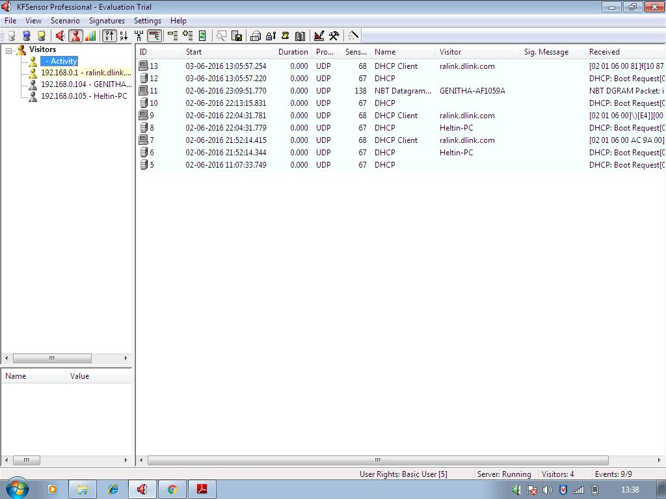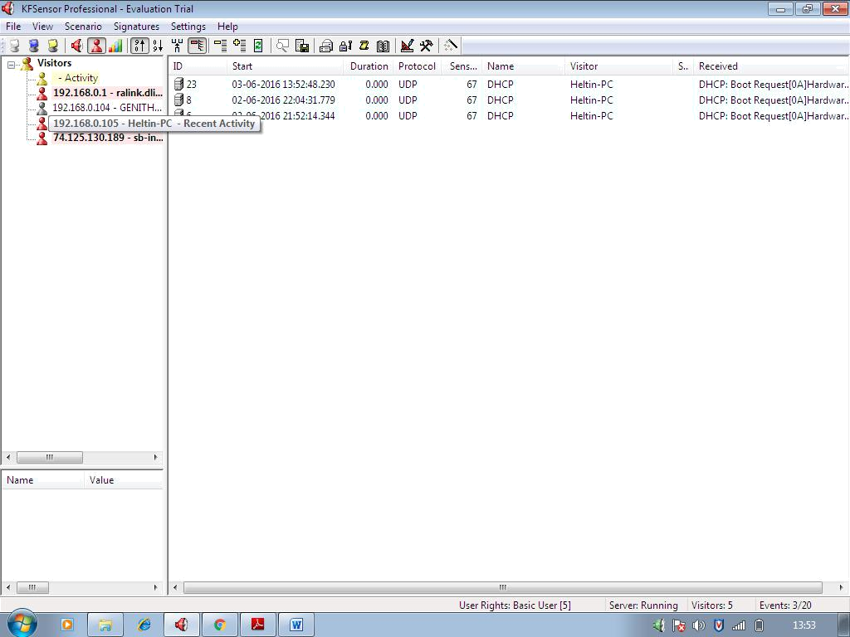

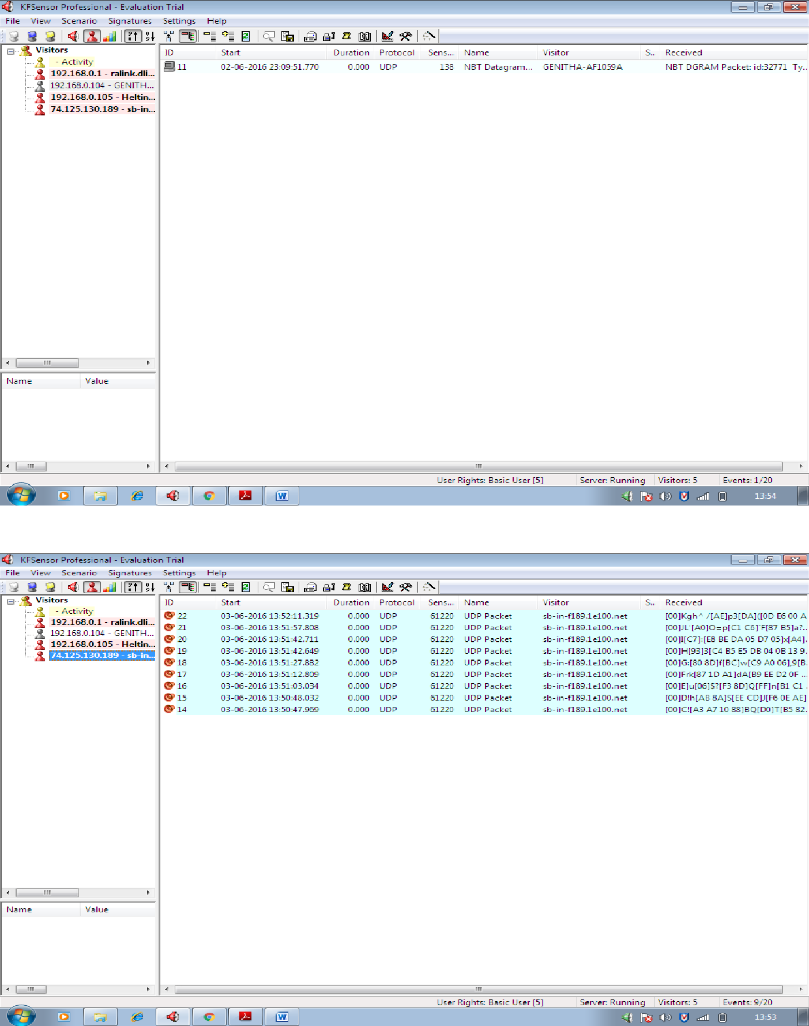

**RESULT**

Thus a honey pot is setup and the honey pot on network is monitored using KF Sensor.

**INSTALLATION OF ROOTKITS AND STUDY OF THE VARIETY OF OPTIONS**

**EX.NO. : 9**

**DATE :**

**AIM**

To install rootkits and study about the variety of options.

**STEPS**

1. Rootkit is a stealth type of malicious software designed to hide the existence of certain process from normal methods of detection and enables continued privileged access to a computer.
2. Download Rootkit Tool from GMER website. (www.gmer.net)
3. This displays the Processes, Modules, Services, Files, Registry, RootKit/Malwares, Autostart, CMD of local host.
4. Select Processes menu and kill any unwanted process if any.
5. Modules menu displays the various system files like .sys, .dll
6. Services menu displays the complete services running with Autostart, Enable, Disable, System, Boot.
7. Files menu displays full files on Hard-Disk volumes.
8. Registry displays Hkey_Current_user and Hkey_Local_Machine.
9. Rootkits/Malawares scans the local drives selected.
10. Autostart displays the registry base Autostart applications.

CMD allows the user to interact with command line utilities or Registry

**EXECUTION:**

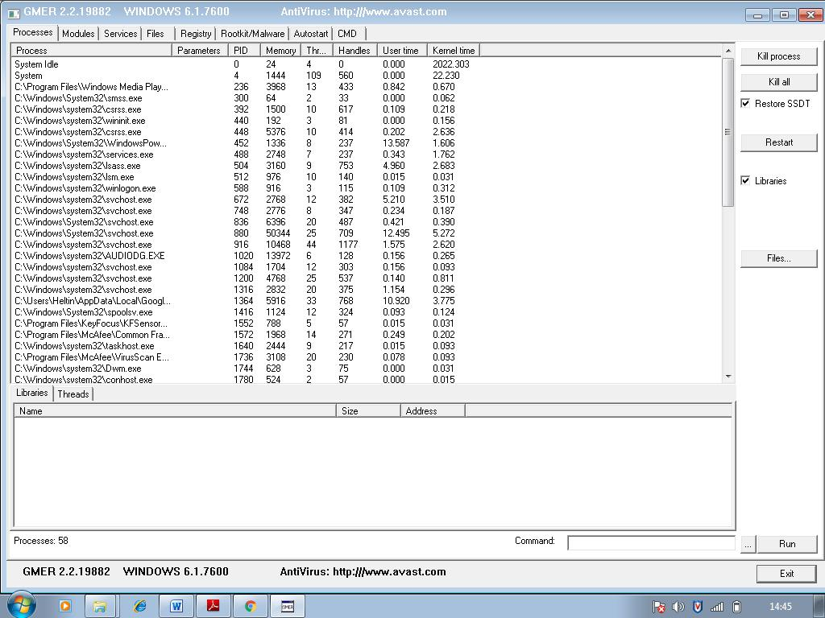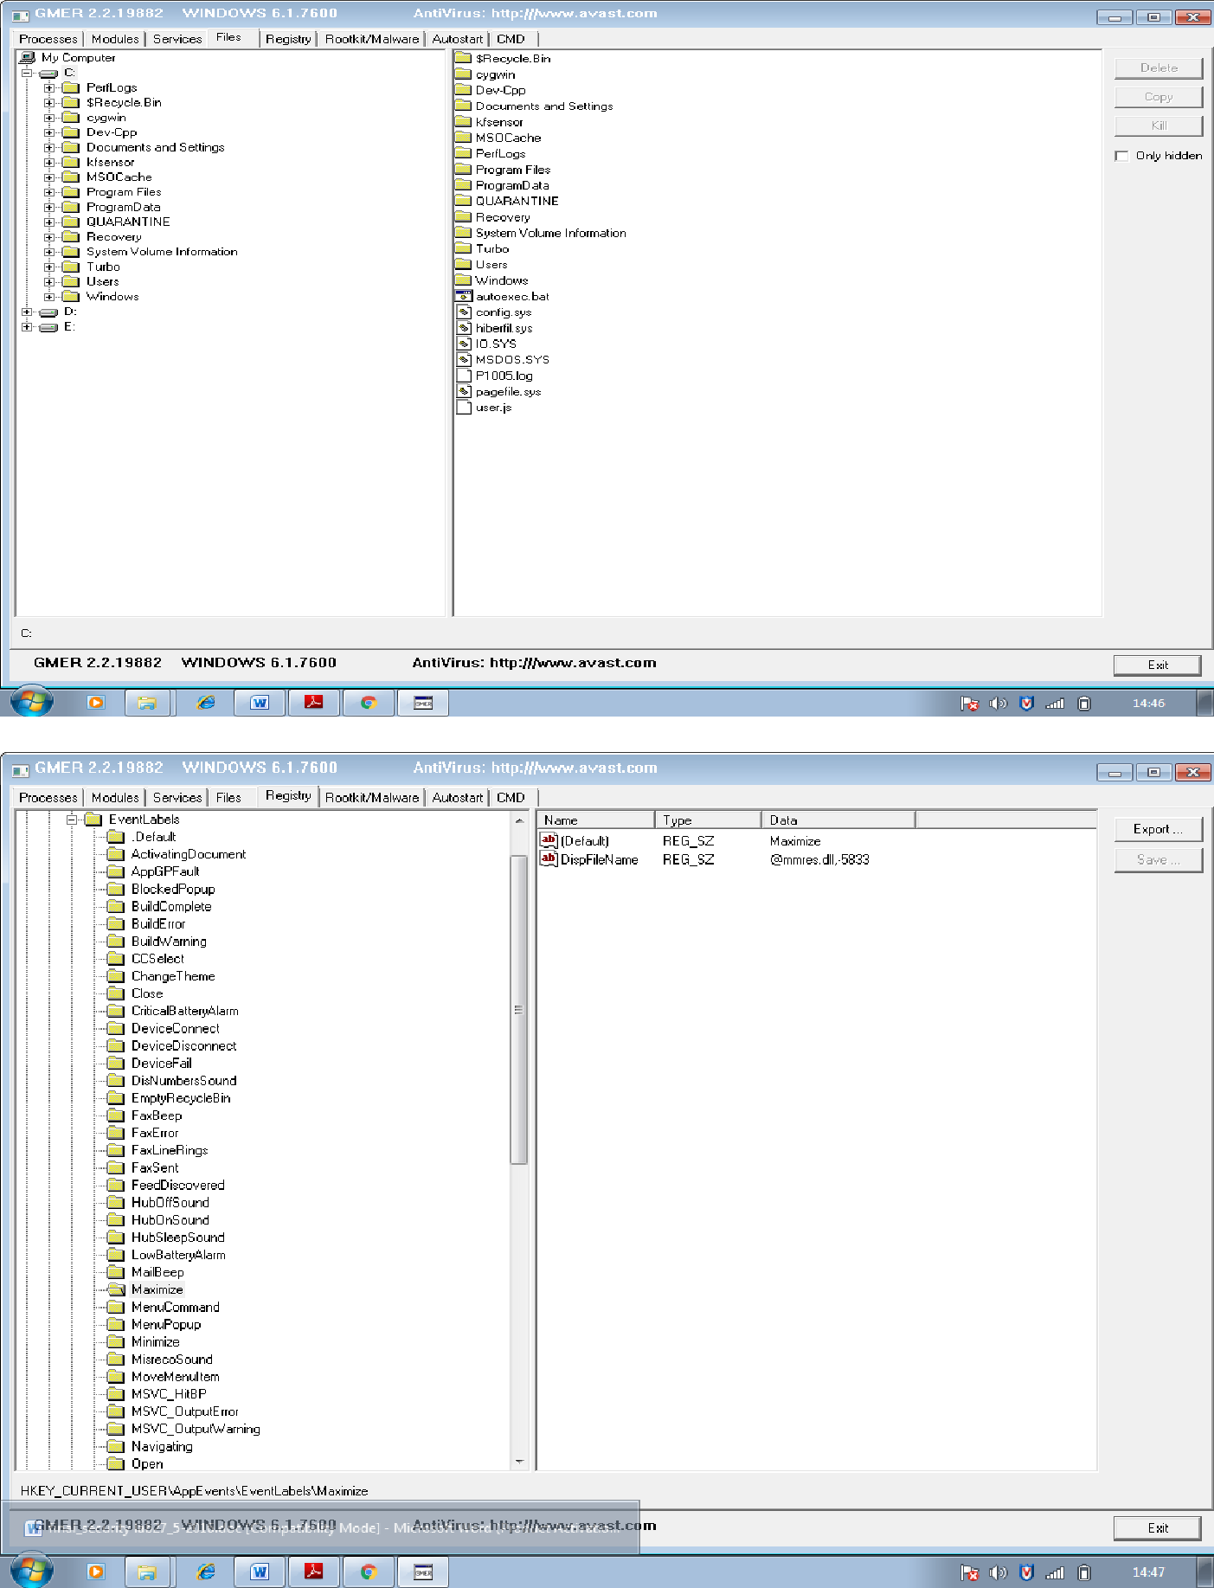

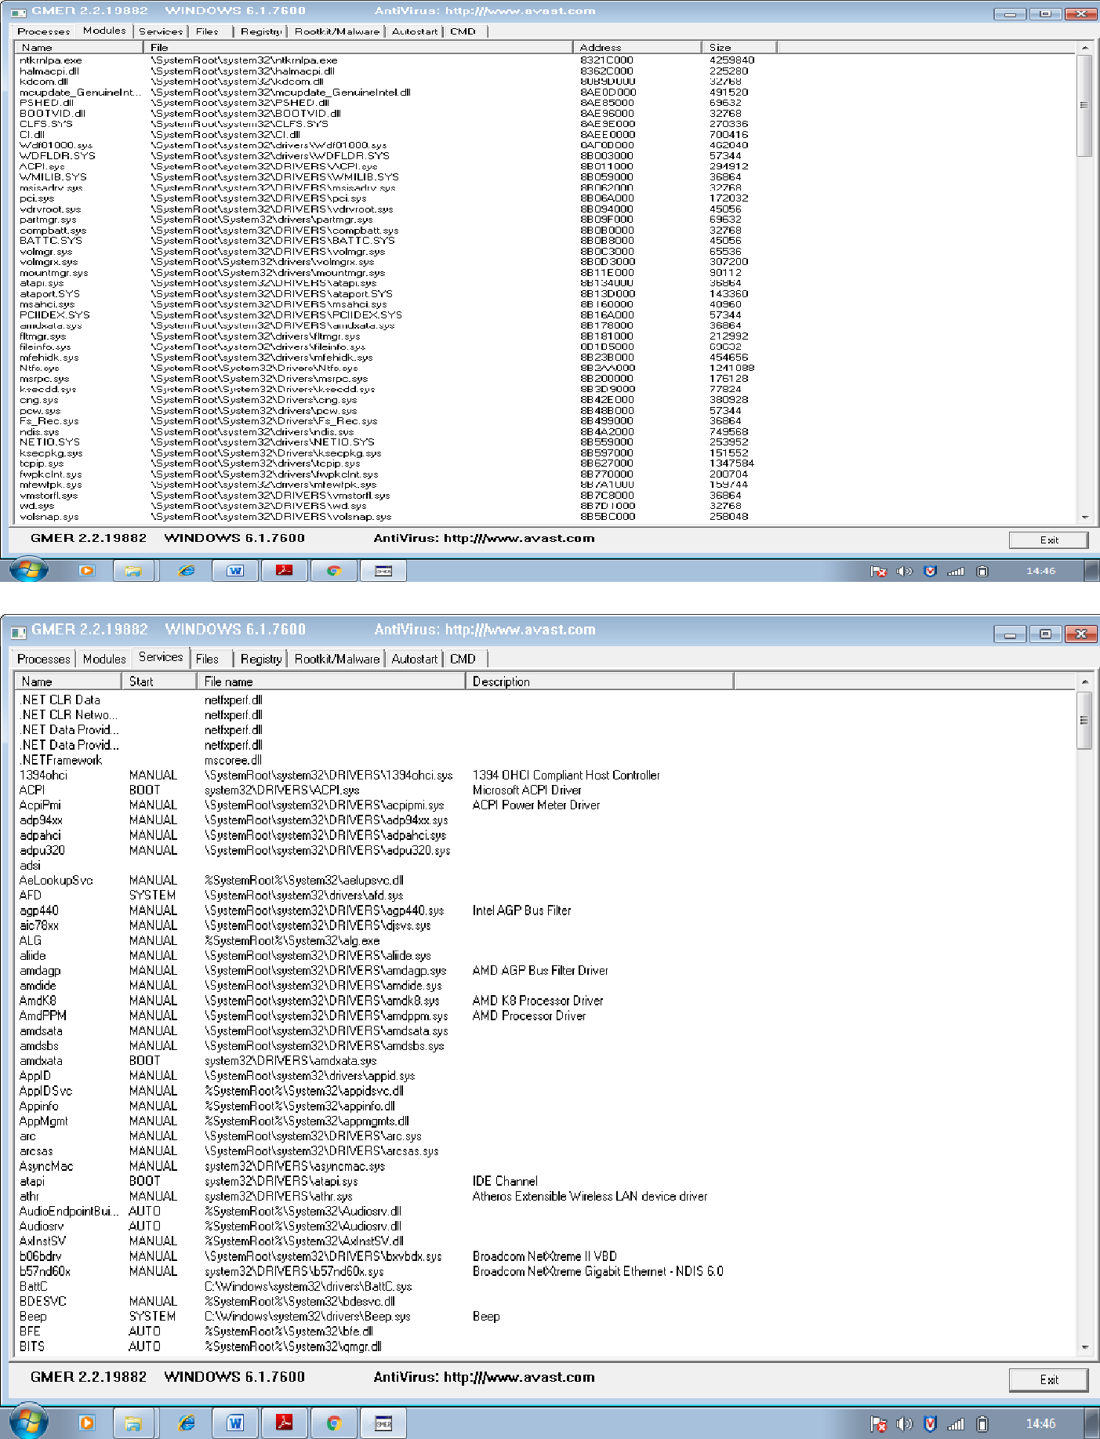

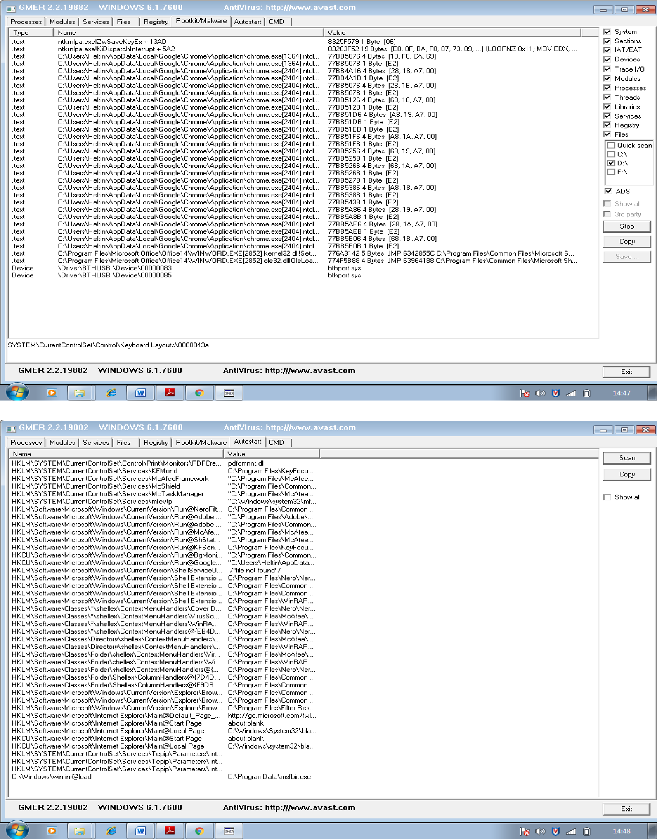

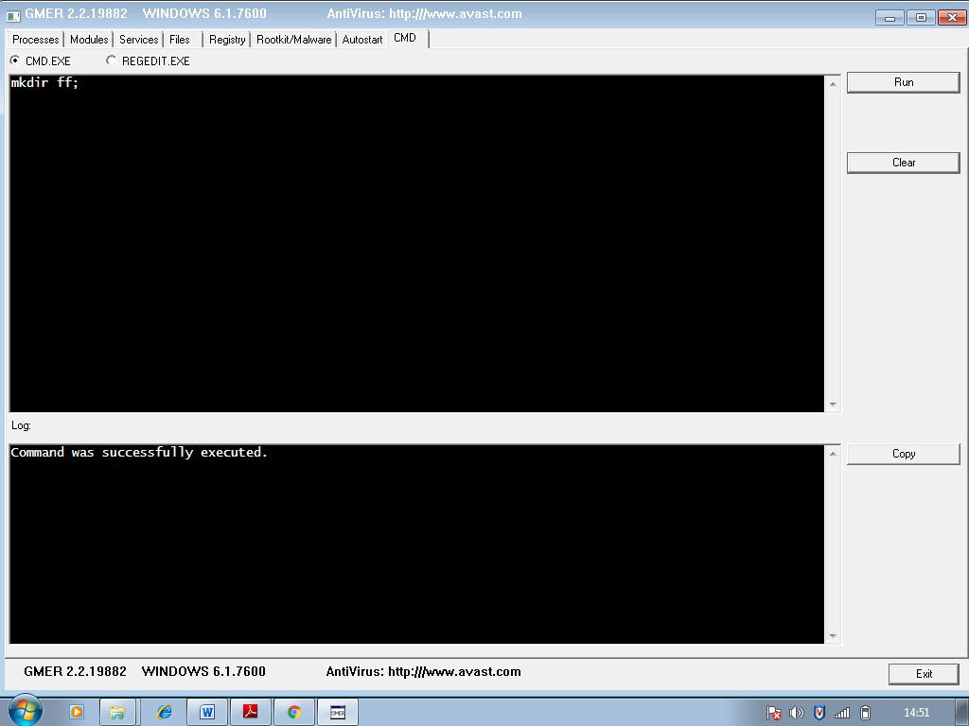

**RESULT**

Thus the rootkits is installed and studied variety of options.

**DEMONSTRATE INTRUSION DETECTION SYSTEM USING SNORT**

**EX.NO. : 10**

**DATE :**

**AIM:**

To demonstrate intrusion detection system using Snort

**INSTALLATION PROCEDURE**

1. Download SNORT from snort.org
2. Install snort with or without database support.
3. Select all the components and Click Next.
4. Install and Close.
5. Skip the WinPcap driver installation
6. Add the path variable in windows environment variable by selecting new classpath.
7. Create a path variable and point it at snort.exe variable name→path and variable value→c:\snort\bin.
8. Click OK button and then close all dialog boxes.
9. Open command prompt and type the commands.

**STEPS**

SNORT can be configured to run in three modes:

1. Sniffer mode 2. Packet Logger mode 3. Network Intrusion Detection System mode

**Sniffer mode**

* 1. snort –v →Print out the TCP/IP packets header on the screen
  2. snort –vd →Show the TCP/IP ICMP header with application data in transit.

**Packet Logger mode**

* 1. snort –dev –l c:\log → snort will automatically know to go into packet logger mode, it collects every packet it sees and places it in log directory.
  2. snort –dev –l c:\log –h ipaddress/24 →This rule tells snort that you want to print out the data link and TCP/IP headers as well as application data into the log directory.
  3. snort –l c:\log –b →This is binary mode logs everything into a single file.

**Network Intrusion Detection System mode**

1. snort –d c:\log –h ipaddress/24 –c snort.conf →This is a configuration file applies rule to each packet to decide it an action based upon the rule type in the file.
2. snort –d –h ipaddress/24 –l c:\log –c snort.conf →This will configure snort to run in its most basic NIDS form, logging packets that trigger rules specifies in the snort.conf

C:\Snort\bin\snort –v

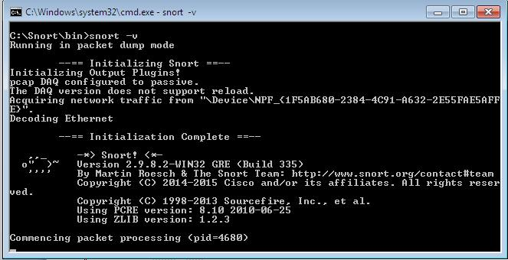

C:\Snort\bin\snort –vd

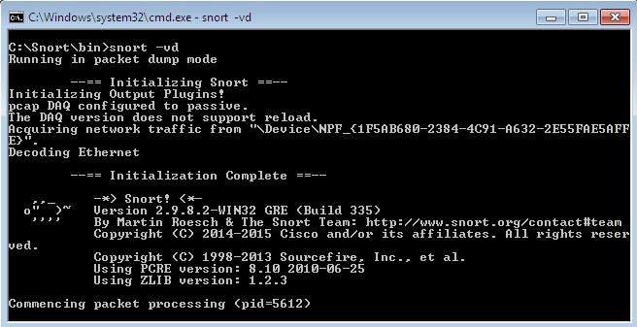

C:\Snort\bin\ snort –dev –l c:\log

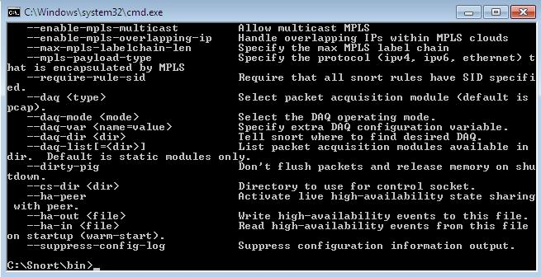

C:\Snort\bin\snort –dev –l c:\log –h ipaddress/24

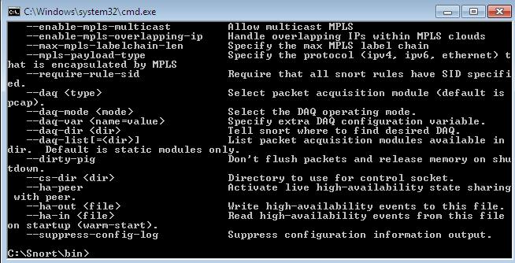

C:\Snort\bin\snort –l c:\log –b

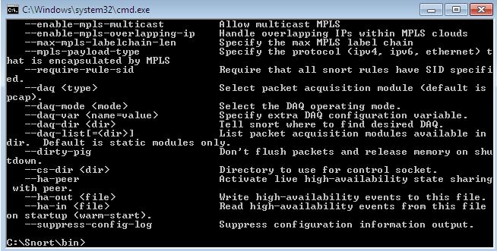

snort –d –h ipaddress/24 –l c:\log –c snort.conf

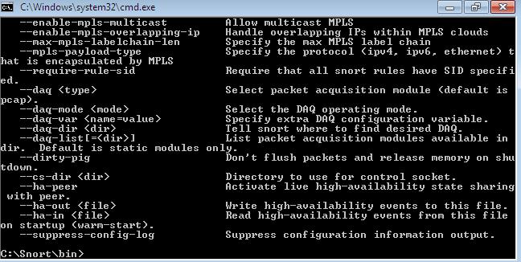

**RESULT:**

Thus the snort IDS Demonstration successfully